PONDICHERRY UNIVERSITY
(A Central University)


SCHOOL OF ENGINEERING AND TECHNOLOGY

DEPARTMENT OF COMPUTER SCIENCE
Master of Computer Science (Data Analytics)

NAME : MURSHIDA P

REG.NO. : 26MSCSCPY0010

SEMESTER : I
SUBJECT : CSDA606 : DESIGN AND ANALYSIS
OF ALGORITHMS LAB

PONDICHERRY UNIVERSITY
(A Central University)

SCHOOL OF ENGINEERING AND TECHNOLOGY

DEPARTMENT OF COMPUTER SCIENCE
Master of Computer Science (Data Analytics)

This is to certify that this is a Bonafide record of practical work done by MURSHIDA P having Reg.No.26MSCSCPY0010 M.Sc. Computer Science (Data Analytics) in I Semester from the month July to November in 2026-2027.

FACULTY IN-CHARGE

SUBMITTED FOR THE PRACTICAL EXAM HELD ON: / /

EXAMINER

INDEX

Ex.  No. | Date | Title | Page | Signature
1. | 28-07-2026 | Binary Search Using Divide and Conquer | 1
2. | 28-07-2026 | Maximum and Minimum  Using  Divide and Conquer | 2
3. | 18-08-2026 | Strassen’s Matrix Multiplication | 3
4. | 18-08-2026 | Job Sequencing Problem  Using Greedy Method | 5
5. | 18-08-2026 | Prim’s Algorithm for MST | 7
6. | 01-09-2026 | Traveling Salesman Problem Using  Dynamic Programming | 9
7. | 15-09-2026 | Sum of Subsets Using Backtracking | 11
8. | 08-09-2026 | Travelling Salesman Problem Using  Branch and Bound | 13

SOURCE CODE :
#include <stdio.h>
int main()
{
int a[100], n, key, low, high, mid, i;
printf("Enter number of elements: ");
scanf("%d", &n);
printf("Enter elements in ascending order:\n");
for(i = 0; i < n; i++)
scanf("%d", &a[i]);
printf("Enter element to search: ");
scanf("%d", &key);
low = 0;
high = n - 1;
while(low <= high)
{
mid = (low + high) / 2;
if(a[mid] == key)
{
printf("Element found at position %d", mid + 1);
return 0;
}
else if(key < a[mid])
high = mid - 1;
else
low = mid + 1;
}
printf("Element not found");
return 0;
}

OUTPUT :
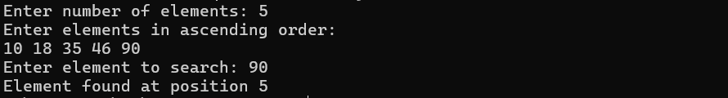

Ex. No: 01
Date: 28-07-2026
BINARY SEARCH USING DIVIDE AND CONQUER

AIM :

ALGORITHM :

RESULT :

1

SOURCE CODE :
#include <stdio.h>
int main()
{
int a[100], n, i, min, max;
printf("Enter number of elements: ");
scanf("%d", &n);
printf("Enter the elements:\n");
for(i = 0; i < n; i++)
scanf("%d", &a[i]);
min = max = a[0];
for(i = 1; i < n; i++)
{
if(a[i] < min)
min = a[i];
if(a[i] > max)
max = a[i];
}
printf("Minimum element = %d\n", min);
printf("Maximum element = %d\n", max);
return 0;
}

OUTPUT :
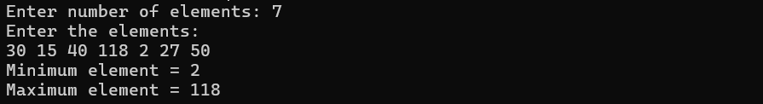

Ex. No: 02
Date: 28-07-2026
MAXIMUM AND MINIMUM USING DIVIDE AND CONQUER

AIM :

ALGORITHM :

RESULT :

2
SOURCE CODE :
#include <stdio.h>
int main()
{
int a[4][4], b[4][4], c[4][4];
int m1[2][2], m2[2][2], m3[2][2], m4[2][2];
int m5[2][2], m6[2][2], m7[2][2];
int p[2][2], q[2][2], r[2][2], s[2][2];
int i, j, k;
printf("Enter elements of matrix A:\n");
for(i = 0; i < 4; i++)
for(j = 0; j < 4; j++)
scanf("%d", &a[i][j]);
printf("Enter elements of matrix B:\n");
for(i = 0; i < 4; i++)
for(j = 0; j < 4; j++)
scanf("%d", &b[i][j]);

for(i = 0; i < 2; i++)
{
for(j = 0; j < 2; j++)
{
m1[i][j] = (a[i][j] + a[i+2][j+2]) * (b[i][j] + b[i+2][j+2]);
m2[i][j] = (a[i+2][j] + a[i+2][j+2]) * b[i][j];
m3[i][j] = a[i][j] * (b[i][j+2] - b[i+2][j+2]);
m4[i][j] = a[i+2][j+2] * (b[i+2][j] - b[i][j]);
m5[i][j] = (a[i][j] + a[i][j+2]) * b[i+2][j+2];
m6[i][j] = (a[i+2][j] - a[i][j]) * (b[i][j] + b[i][j+2]);
m7[i][j] = (a[i][j+2] - a[i+2][j+2])* (b[i+2][j] + b[i+2][j+2]);
}
}

Ex. No: 03
Date: 18-08-2026
STRASSEN’S MATRIX MULTIPLICATION

AIM :

ALGORITHM :

3
for(i = 0; i < 2; i++)
{
for(j = 0; j < 2; j++)
{
c[i][j] = m1[i][j] + m4[i][j] - m5[i][j] + m7[i][j];
c[i][j+2] = m3[i][j] + m5[i][j];
c[i+2][j] = m2[i][j] + m4[i][j];
c[i+2][j+2] = m1[i][j] - m2[i][j] + m3[i][j] + m6[i][j];
}
}
printf("Result matrix:\n");
for(i = 0; i < 4; i++)
{
for(j = 0; j < 4; j++)
printf("%d ", c[i][j]);
printf("\n");
}
return 0;
}

OUTPUT :
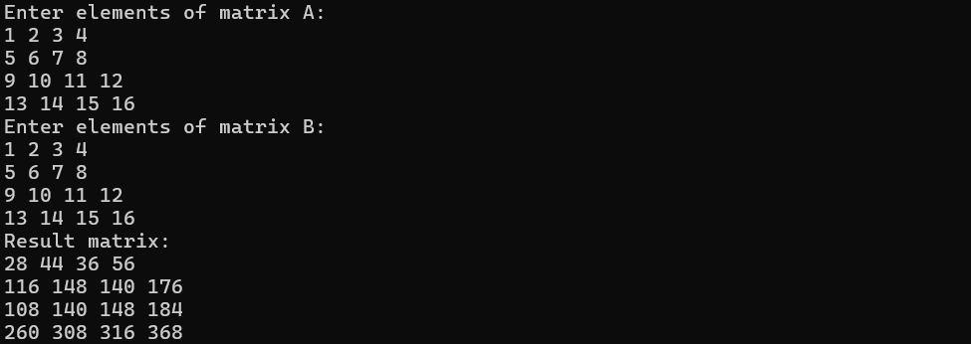

RESULT :

4
SOURCE CODE :
#include <stdio.h>
int main()
{
int n, i, j, max = 0, total = 0, temp;
int deadline[20], profit[20], job[20];
int slot[20], maxDeadline = 0;
printf("Enter number of jobs: ");
scanf("%d", &n);
printf("Enter job ID, deadline and profit:\n");
for(i = 0; i < n; i++)
{
scanf("%d%d%d", &job[i], &deadline[i], &profit[i]);
if(deadline[i] > maxDeadline)
maxDeadline = deadline[i];
}
for(i = 0; i < n - 1; i++)
{
for(j = 0; j < n - i - 1; j++)
{
if(profit[j] < profit[j + 1])
{
temp = profit[j];
profit[j] = profit[j + 1];
profit[j + 1] = temp;
temp = deadline[j];
deadline[j] = deadline[j + 1];
deadline[j + 1] = temp;
temp = job[j];
job[j] = job[j + 1];
job[j + 1] = temp;
}
}

Ex. No: 04
Date: 18-08-2026
JOB SEQUENCING USING GREEDY METHOD

AIM :

ALGORITHM :

5
}
for(i = 0; i < maxDeadline; i++)
slot[i] = -1;

for(i = 0; i < n; i++)
{
for(j = deadline[i] - 1; j >= 0; j--)
{
if(slot[j] == -1)
{
slot[j] = job[i];
total += profit[i];
break;
}
}
}
printf("\nJob Schedule:\n");
for(i = 0; i < maxDeadline; i++)
{
if(slot[i] != -1)
printf("Slot %d: Job %d\n", i + 1, slot[i]);
}
printf("Maximum Profit = %d\n", total);
return 0;
}

OUTPUT :
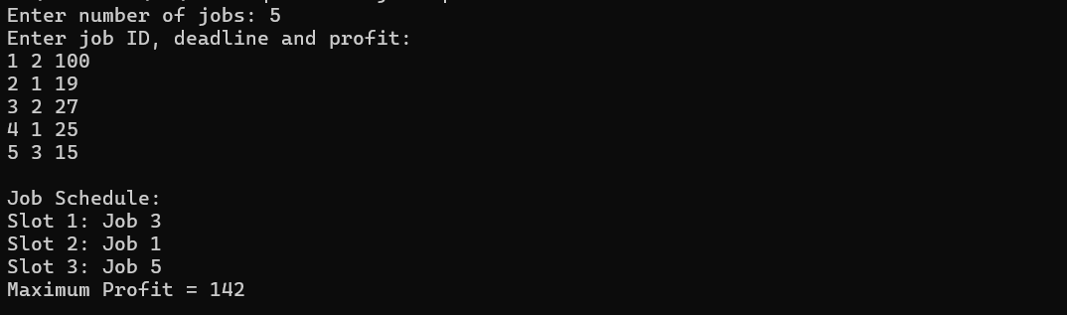

RESULT :

6
SOURCE CODE :
#include <stdio.h>
int main()
{
int a[20][20], visited[20] = {0};
int n, i, j, edges = 0;
int min, u = 0, v = 0, total = 0;
printf("Enter number of vertices: ");
scanf("%d", &n);
printf("Enter adjacency matrix (0 for no edge):\n");
for(i = 0; i < n; i++)
for(j = 0; j < n; j++)
scanf("%d", &a[i][j]);
visited[0] = 1;
printf("Edges in MST:\n");
while(edges < n - 1)
{
min = 999999;
for(i = 0; i < n; i++)
{
if(visited[i])
{
for(j = 0; j < n; j++)
{
if(!visited[j] && a[i][j] != 0 && a[i][j] < min)
{
min = a[i][j];
u = i;
v = j;
}
}
}
}

Ex. No: 05
Date: 18-08-2026
PRIM’S ALGORITHM FOR MST

AIM :

ALGORITHM :

7
if(min == 999999)
{
printf("Graph is disconnected\n");
return 0;
}
printf("%d - %d : %d\n", u, v, min);
visited[v] = 1;
total += min;
edges++;
}
printf("Total weight = %d\n", total);
return 0;
}

OUTPUT :
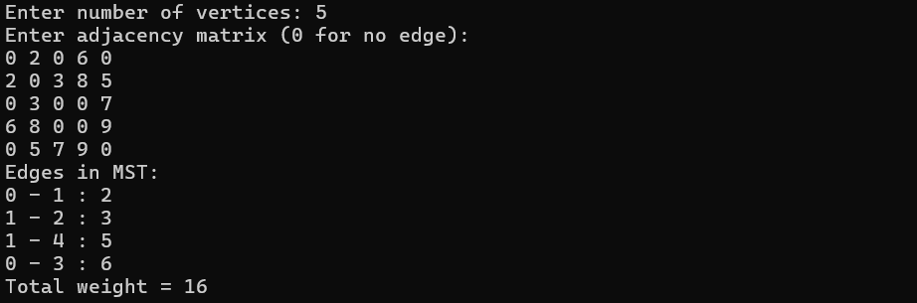

RESULT :

8

SOURCE CODE :
#include <stdio.h>
int cost[10][10], path[10], bestPath[10];
int visited[10], n, minCost = 999999;
void tsp(int city, int count, int total)
{
int i;
if(count == n)
{
if(cost[city][0] != 0 &&
total + cost[city][0] < minCost)
{
minCost = total + cost[city][0];
for(i = 0; i < n; i++)
bestPath[i] = path[i];
}
return;
}
for(i = 1; i < n; i++)
{
if(!visited[i] && cost[city][i] != 0)
{
visited[i] = 1;
path[count] = i;
tsp(i, count + 1, total + cost[city][i]);
visited[i] = 0;
}
}
}
int main()
{
int i, j;
printf("Enter number of cities (maximum 10): ");

Ex. No: 06
Date: 01-09-2026
TRAVELLING SALESMAN PROBLEM USING
DYNAMIC PROGRAMMING

AIM :

ALGORITHM :

9
scanf("%d", &n);
if(n < 2 || n > 10)
{
printf("Invalid number of cities");
return 0;
}
printf("Enter cost matrix (0 for no route):\n");
for(i = 0; i < n; i++)
for(j = 0; j < n; j++)
scanf("%d", &cost[i][j]);
path[0] = 0;
visited[0] = 1;
tsp(0, 1, 0);
if(minCost == 999999)
printf("No complete tour exists\n");
else
{
printf("Minimum cost: %d\n", minCost);
printf("Tour: ");
for(i = 0; i < n; i++)
printf("%d -> ", bestPath[i]);
printf("0\n");
}
return 0;
}

OUTPUT :
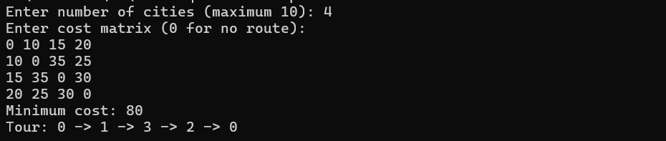

RESULT :

101
SOURCE CODE :
#include <stdio.h>
int a[20], x[20], n, target;
void sumOfSubsets(int i, int sum)
{
int j;
if(sum == target)
{
printf("{ ");
for(j = 0; j < i; j++)
if(x[j] == 1)
printf("%d ", a[j]);
printf("}\n");
return;
}
if(i == n || sum > target)
return;
x[i] = 1;
sumOfSubsets(i + 1, sum + a[i]);
x[i] = 0;
sumOfSubsets(i + 1, sum);
}

int main()
{
int i;
printf("Enter number of elements: ");
scanf("%d", &n);
printf("Enter the elements:\n");
for(i = 0; i < n; i++)
scanf("%d", &a[i]);
printf("Enter target sum: ");

Ex. No: 07
Date: 15-09-2026
SUM OF SUBSETS USING BACKTRACKING

AIM :

ALGORITHM :

11
scanf("%d", &target);
printf("Subsets with sum %d:\n", target);
sumOfSubsets(0, 0);
return 0;
}

OUTPUT :
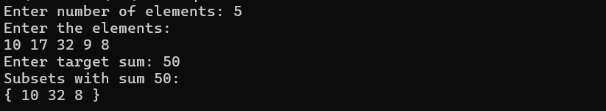

RESULT :

12
SOURCE CODE :
#include <stdio.h>
int n, cost[10][10], visited[10];
int path[10], bestPath[10];
int minCost = 999999;
void tsp(int city, int count, int total)
{
int i;
if(count == n)
{
if(cost[city][0] != 0)
{
total += cost[city][0];
if(total < minCost)
{
minCost = total;
for(i = 0; i < n; i++) bestPath[i] = path[i];
}
}
return;
}
for(i = 0; i < n; i++)
{
if(!visited[i] && cost[city][i] != 0)
{
if(total + cost[city][i] < minCost)
{
visited[i] = 1;
path[count] = i;
tsp(i, count + 1, total + cost[city][i]);
visited[i] = 0;
}
}

Ex. No: 08
Date: 08-09-2026
TRAVELLING SALESMAN PROBLEM
USING BRANCH AND BOUND

AIM :

ALGORITHM :

13
}
}
int main()
{
int i, j;
printf("Enter number of cities: ");
scanf("%d", &n);
printf("Enter cost matrix (0 for no path):\n");
for(i = 0; i < n; i++)
for(j = 0; j < n; j++)
scanf("%d", &cost[i][j]);
visited[0] = 1;
path[0] = 0;
tsp(0, 1, 0);
if(minCost == 999999)
printf("No valid tour exists.\n");
else
{
printf("Optimal tour: ");
for(i = 0; i < n; i++)
printf("%d -> ", bestPath[i]);
printf("0\n");
printf("Minimum cost = %d\n", minCost);
}
return 0;
}

OUTPUT :
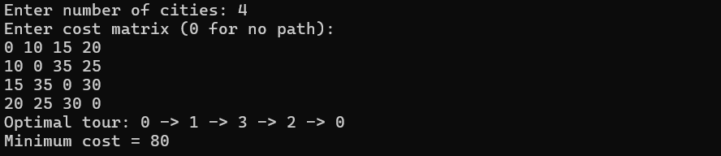

RESULT :

14

